Appendix 2.2 Analysis of the Gulf of Alaska Bottom Trawl survey restratification for Pacific cod
Pete Hulson, Zack Oyafuso, and Stan Kotwicki

Executive Summary
In 2025, the Alaska Fisheries Science Center’s (AFSC) Gulf of Alaska (GOA) bottom trawl survey transitioned to an updated stratified design (hereafter the ‘restratified design’). This survey design restratification was implemented to increase sampling efficiency while maintaining unbiased estimates of population indices and composition data that are used within stock assessments conducted by the AFSC. This restratified design was rigorously developed and implemented, having undergone extensive simulation evaluation (ref) and review by management bodies (e.g., NPFMC Plan Team and SSC) prior to implementation in 2025.
In this appendix we compared the historical bottom trawl survey’s time-series of design-based estimates of biomass and abundance to what the estimates could have been under the restratified design. We use GOA Pacific cod as an example species because it is well sampled and consistently distributed across the continental shelf of the GOA. We find that the historical indices of biomass and abundance are remarkably similar to the estimates under the restratified design. We conclude that the restratified design of the GOA bottom trawl survey provides consistent estimates with the historical time-series of important indices in both magnitude and trend. Furthermore, the 2025 estimates of biomass and abundance for Pacific cod under the restratified design follow and continue the recent trends observed in the population. We emphasize that the restratified design maintains a robust time-series of indices provided by the GOA bottom trawl survey that are based upon unbiased sampling designs and provide our best information available to understand population trends for stocks assessed within the GOA.

Data
Data used in this analysis included historical haul-level area-swept CPUE (in kg per km² for biomass estimation and in numbers per km² for abundance estimation) from the AFSC GOA bottom trawl survey. The time-series of the surveys investigated were triennially from 1990-1999, then biennially from 1999-2023.

Analytic Approach
To assess how the restratified survey design might have impacted historical biomass and abundance indices for GOA Pacific cod, we employed a two-step reanalysis. First, historical hauls were spatially reassigned to the new strata. Second, we calculated the standard design-based indices by multiplying the strata-specific mean CPUE by the respective strata area and summing the results.
We acknowledge these are naïve design-based estimates. A more rigorous approach would utilize a Hansen-Hurwitz estimator to account for the selection probability of each historical haul location under the new design. However, for a consistently distributed and well-sampled species like Pacific cod, we expect any bias introduced by the naïve estimator to be negligible. Because our primary objective was to detect substantial shifts in trend or magnitude rather than to provide precise variance, we present only the point estimates here. We recommend that any future efforts to quantify uncertainty for this historical reanalysis utilize a more rigorous estimator.

Results
Reanalysis of the historical GOA bottom trawl survey reveals high consistency between the original time-series and the restratified design (Figures 2.2.1 and 2.2.2). GOA-wide biomass and abundance estimates (Figure 2.2.1) align most closely during periods of lower magnitude (e.g., 1990–2007 and 2015–2023), with minor divergence occurring during peak years (2009–2013). Since 2017, the two time-series have been nearly indistinguishable. Notably, the reanalyzed indices fell outside the historical 95% confidence intervals in only a single year (abundance in 2013). However, it is likely that historical uncertainty was underestimated due to the survey’s previous over-stratification. The 2025 indices under the restratified design continue the established historical trends in both magnitude and direction.
These patterns persist at the subregional scale (Figure 2.2.2). While the Western and Central GOA showed extreme consistency between the original time-series and the restratified design, the Eastern GOA exhibited larger discrepancies. This subregion typically supports a smaller, more patchily distributed Pacific cod population, leading to historically high inter-annual variability and large uncertainty—particularly when biomass estimates exceed the time-series mean. The 2025 Eastern GOA index, while lower than recent years, remains within the historical range of biomass estimates in this subregion.
We expect that for stocks or subregions with lower sampling density, comparisons between historical and restratified indices will mirror the Pacific cod Eastern GOA results. For such stocks, indices will remain variable with high uncertainty regardless of post-stratification. While differences between the original and restratified time-series may appear larger for these species, this does not invalidate the restratified design. Rather, the remarkable consistency observed in well-sampled stocks like Pacific cod demonstrates that the new design continues an unbiased design for the GOA bottom trawl survey and is functioning as intended. For species with inherently patchy distributions (e.g., rockfish), no stratification design can fully overcome inherent sampling variability that then translates through to survey indices. Furthermore, for such species, within a reanalysis of historical survey data like undertaken for Pacific cod it is statistically impossible to disentangle the effects of the restratified survey design from the natural variability and "zero-heavy" catch data associated with their distributions.

Literature Cited
Barbeaux. S. J., K. Aydin, B. Fissel, K. Holsman, B. Laurel, W. Palsson, L. Rogers, K. Shotwell, Q. Yang, and S. Zador. 2019. Assessment of the Pacific cod stock in the Gulf of Alaska. In Stock assessment and fishery evaluation report for the groundfish resources of the Gulf of Alaska. North Pacific Fishery Management Council, 605 W. 4th Avenue Suite 306, Anchorage, AK 99501

Figures

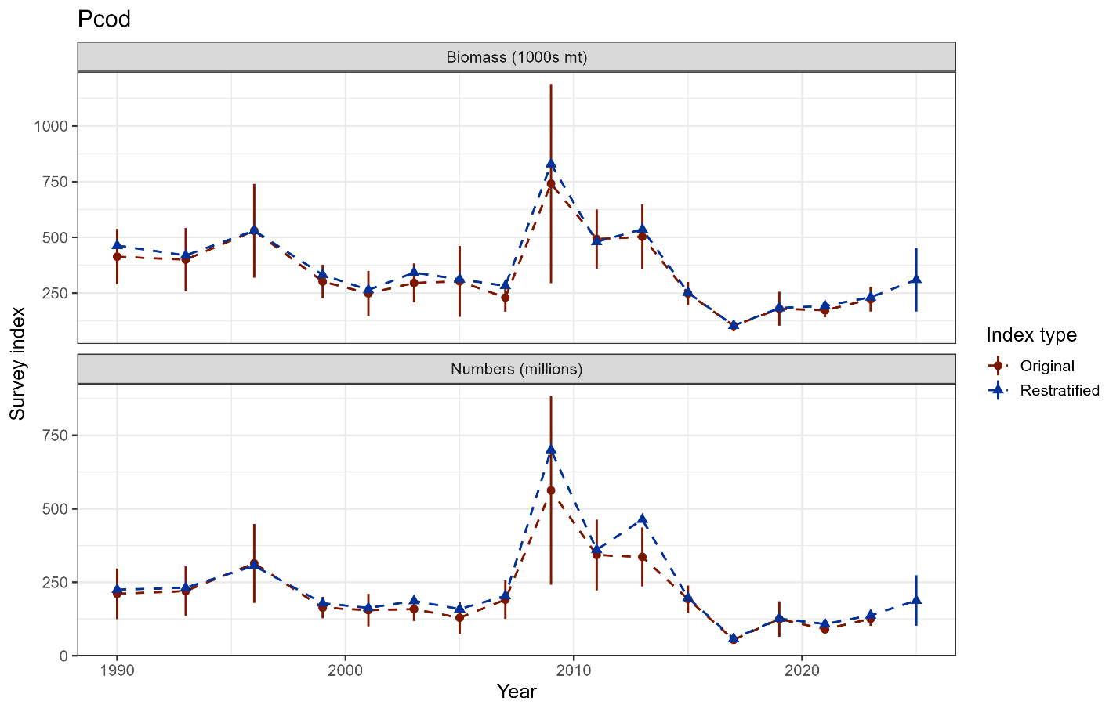

Figure 2.2.1. GOA bottom trawl survey population indices for Pacific cod from the original design-based estimates and the reanalyzed design-based estimates under the restratified survey design.

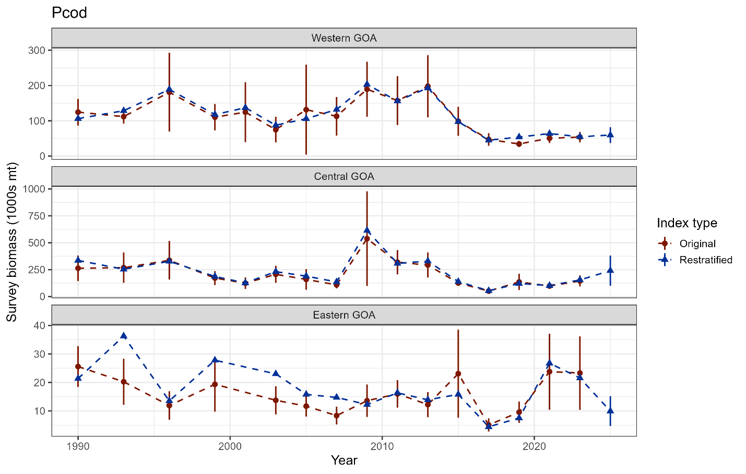

Figure 2.2.2. GOA subregion bottom trawl survey biomass indices for Pacific cod from the original design-based estimates and the reanalyzed design-based estimates under the restratified survey design.

